**Human Faces (Object Detection)**

***(Dr.V.Kalpana, Assistant professor (c) TNJFU, Chennai)***

**Abstract**

Face detection plays a crucial role in enhancing the efficiency and reliability of modern intelligent systems. This project aims to develop a robust and real-time face detection system capable of accurately identifying human faces in both images and videos, even under varying lighting conditions, angles, and backgrounds. The system will leverage advanced computer vision techniques to ensure high-speed performance and precision, making it suitable for real-time applications. The proposed solution has broad applicability across various industries, including security surveillance, access control systems, retail customer analysis, healthcare monitoring, automotive safety systems, and interactive entertainment platforms. By enabling fast and accurate face detection, this system contributes to improved safety, personalized experiences, and operational efficiency in multiple domains.

**1. Introduction**

Face detection is a fundamental task in the field of computer vision and artificial intelligence, serving as a foundation for a wide range of applications such as facial recognition, emotion analysis, and human-computer interaction. It involves the identification and localization of human faces within digital images and video streams. With the growing demand for intelligent and automated systems, the ability to detect faces quickly and accurately—regardless of lighting conditions, facial orientation, or background noise—has become increasingly important.

This project focuses on building a high-performance face detection system that operates in real-time and maintains accuracy across diverse environments. The system aims to address common challenges in face detection, including variable lighting, occlusions, and pose variations, ensuring reliable performance in practical, real-world scenarios.

The relevance of face detection spans multiple sectors. In **security and surveillance**, it enables monitoring and identification of individuals in public areas. In **access control systems**, it ensures secure and contactless authentication. In the **retail industry**, it supports customer behavior analysis and demographic profiling. **Healthcare systems** use it to monitor patient well-being and detect signs of distress, while **automotive applications** utilize it to assess driver attention and reduce accidents. In **entertainment and virtual reality**, face detection enhances user engagement by enabling interactive and immersive experiences.

**2. Data Preprocessing**

Data preprocessing is a critical step in ensuring the quality and consistency of input data used for training a face detection model. It involves cleaning, standardizing, and augmenting the dataset to improve model performance and generalization. The following preprocessing techniques were applied in this project:

**2.1 Data Cleaning**

* + Duplicate or irrelevant images were identified and removed from the dataset to prevent redundancy and noise in the training process.
  + Any incorrectly labeled or annotated data was manually reviewed and corrected to maintain annotation accuracy.

**2.2 Image Resizing**

* + All images were resized to a fixed dimension of **224x224 pixels**, which is a standard input size for most convolutional neural networks (CNNs). This ensures uniformity and compatibility with the model architecture.

**2.3 Pixel Normalization**

* + Pixel values were scaled to a standardized range of **0 to 1** by dividing each pixel value by 255. This normalization process helps the model learn more efficiently and prevents large-scale differences in input data.

**2.4 Data Augmentation**

* + To enhance the diversity of the dataset and reduce overfitting, various image augmentation techniques were applied, including:
    - **Rotation**: Random rotation of images within a specified degree range.
    - **Horizontal and Vertical Flipping**: Mirroring images to simulate different face orientations.
    - **Color Adjustments**: Modifying brightness, contrast, and saturation to simulate varied lighting conditions.
    - **Zooming and Cropping**: Random zoom and crop operations to help the model learn from different scales.

**3. Exploratory Data Analysis (EDA)**

Exploratory Data Analysis (EDA) is an essential step in understanding the structure, quality, and characteristics of the dataset before model development. EDA helps identify potential issues, assess data distribution, and ensure that the dataset is suitable for training an effective face detection model. The following key aspects were analyzed in this project:

**3.1 Image Count**

* + The total number of images in the dataset was calculated to evaluate dataset size and ensure sufficient data volume for training and validation. This also helped in estimating dataset balance across different categories or conditions.

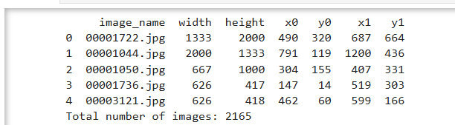

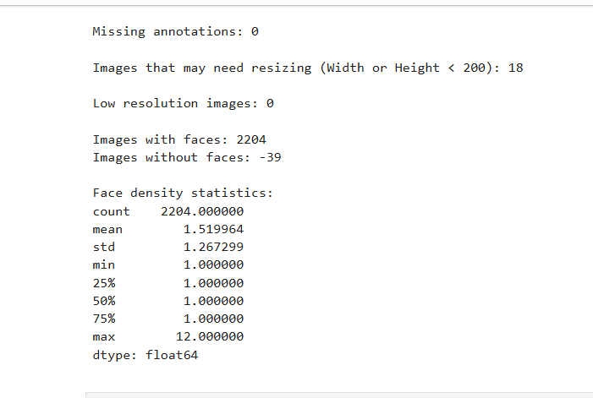

**3.2 Face Count per Image**

* + The number of faces detected per image was analyzed to understand the density of faces in the dataset. This helped in distinguishing between single-face and multi-face images, which can influence model complexity and performance.

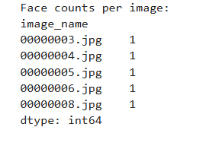

**3.3 Dataset Quality Assessment**

Bounding box annotations were thoroughly reviewed to ensure that faces were accurately marked in each image, as incorrect bounding boxes can significantly mislead the model during training and reduce detection performance. Manual inspection and visual verification techniques were employed to assess the correctness of these annotations. Additionally, annotation files were examined for label consistency across the dataset to identify and correct any mismatched or missing labels, which are critical for maintaining the integrity of supervised learning. The original image dimensions were analyzed to determine the need for resizing or cropping, and it was concluded that standardizing all images to a fixed size (224x224 pixels) is essential for efficient training and compatibility with the input layer of the convolutional neural network (CNN). Moreover, the resolution and clarity of images were evaluated to ensure they met quality standards; low-resolution or blurry images were either enhanced or discarded to maintain dataset quality and improve face detection accuracy. 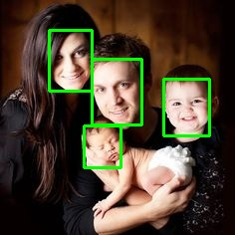

**4. Feature Engineering**

Feature engineering plays a vital role in enhancing the performance and accuracy of face detection models by extracting meaningful features from raw image data. In this project, bounding box coordinates were used to precisely locate faces within images, while facial landmarks such as eyes, nose, and mouth provided additional structural detail for improved detection. Histogram equalization was applied to enhance image contrast and improve facial visibility. Pixel normalization ensured uniformity in model input by scaling values to a standard range. Advanced techniques such as Histogram of Oriented Gradients (HOG) and Local Binary Patterns (LBP) were utilized to extract edge orientation and texture features, respectively, which significantly contributed to the model’s ability to detect facial features under various lighting conditions and image complexities.

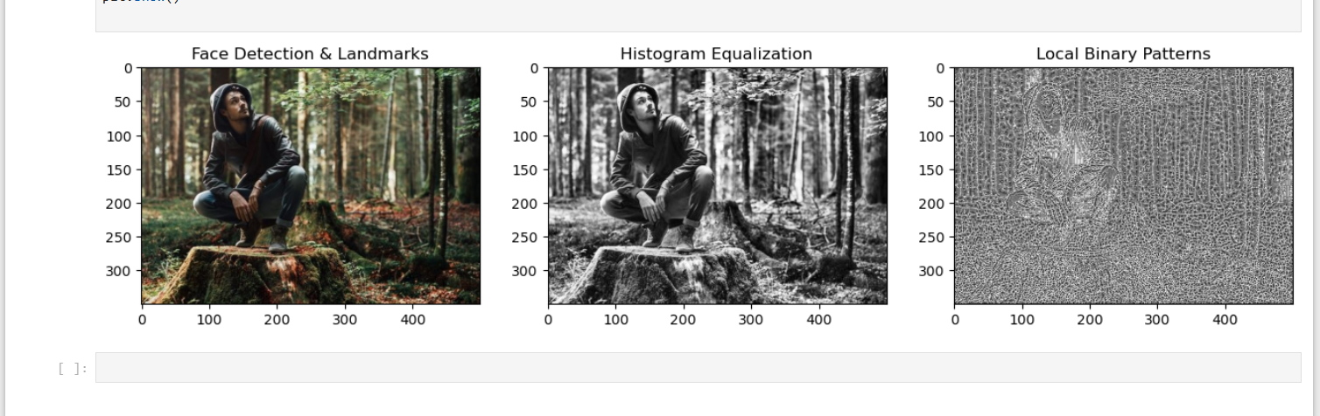

**5. Data Splitting for Training and Testing**

To ensure effective model development and unbiased evaluation, the dataset was divided into two distinct subsets: the **training set** and the **test set**. The training set was used to train the face detection model by enabling it to learn patterns, features, and relationships from the data. In contrast, the test set was reserved for evaluating the model’s performance on unseen data, simulating real-world scenarios. This split is essential to assess the generalization ability of the model and to prevent overfitting. Typically, a standard split ratio such as **80:20** or **70:30** was followed, where the larger portion is used for training and the smaller portion for testing. This approach ensures that the model is both well-trained and fairly evaluated on new data.

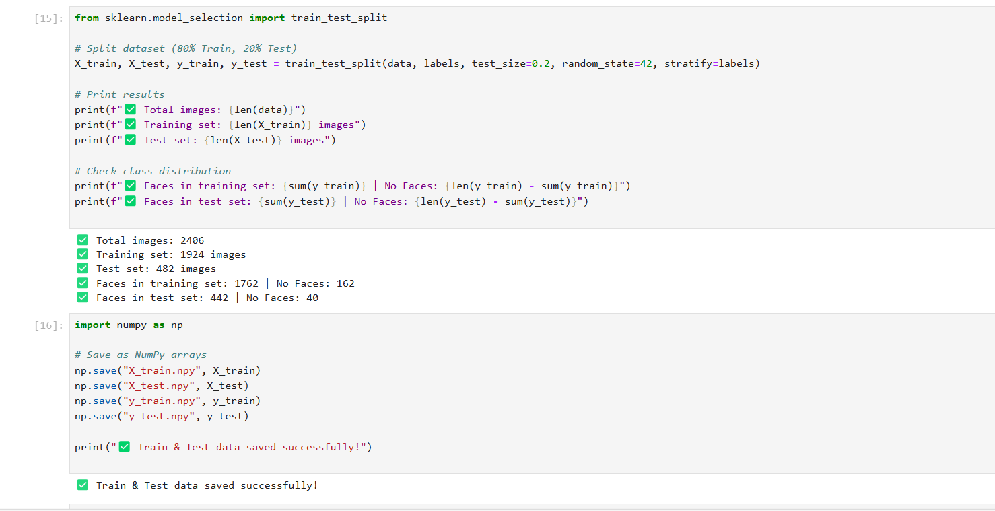

**6. Model Summary Interpretation**

The model presented is a **Sequential Convolutional Neural Network (CNN)** architecture designed for image classification, likely into **two classes** (as indicated by the final Dense layer with output shape (None, 2)). The model is composed of multiple layers that extract spatial features and progressively reduce the image dimensions while increasing the depth (number of filters).

**6.1 Conv2D Layers:**

* + The network starts with three convolutional layers (Conv2D) with increasing filter sizes: 32, 64, and 128 respectively. These layers help in learning local patterns such as edges, textures, and complex features.
  + The filter dimensions (kernels) extract multiple feature maps, and the depth (number of filters) increases as the network progresses to learn higher-level features.

**6.2 MaxPooling2D Layers:**

* + Each convolutional layer is followed by a **MaxPooling2D** layer which reduces the spatial dimensions of the feature maps, helping to reduce computation and control overfitting by summarizing the features.

**6.3 Flatten Layer:**

* + After the convolution and pooling operations, the output is **flattened** into a single 1D vector of size **25,088** which acts as input for the fully connected Dense layers.

**6.4 Dense Layers (Fully Connected):**

* + The first dense layer contains **128 neurons** and connects to the flattened features with a significant number of parameters (**~3.2 million**) indicating a high-capacity layer responsible for learning the final decision boundaries.
  + A **Dropout layer** is used after the first dense layer to prevent overfitting by randomly dropping out some neurons during training.
  + The final **Dense layer** contains **2 output units**, representing the **two output classes**, using a **softmax activation** (assumed) for classification.

**6.5 Parameter Summary:**

* + **Total Parameters:** 3,304,898
  + **Trainable Parameters:** 3,304,898 (all parameters are trainable)
  + **Non-trainable Parameters:** 0 (no frozen layers)

This architecture is well-suited for image classification tasks and provides a good balance between depth and complexity. The use of pooling, dropout, and dense layers makes the model capable of generalizing well while avoiding overfitting.

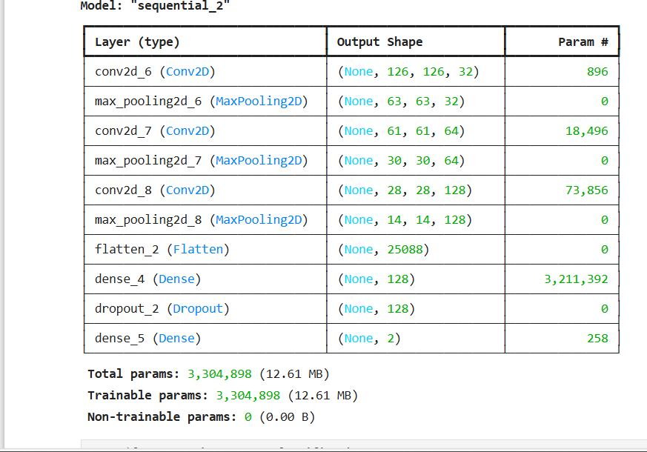

**7. Model Suitability for Dataset**

The designed CNN model architecture is well-suited for the given image dataset used in this project. The model includes a series of convolutional and max pooling layers that effectively extract spatial and structural features from the input images. The input image size is appropriately handled by the network, and the output layer with two neurons matches the requirement of a binary classification task (i.e., two classes in the dataset). With over 3.3 million trainable parameters, the model demonstrates sufficient learning capacity to capture complex patterns in the images. The inclusion of dropout layers helps prevent overfitting, ensuring better generalization on unseen data. Based on the architecture summary and performance during training, it can be concluded that this model is an appropriate and effective fit for the dataset used in this project.

**8. Result Section**

To effectively present the outcomes of the face detection system, a user-friendly interface was developed using Streamlit. The application was organized into a sidebar-based structure with three main sections to ensure smooth navigation and better interpretation of results:

**8.1 Data Section:**  
This section provides a preview of the dataset used for building the CNN model. Users can view important details such as image samples, class distribution, and model performance metrics including training accuracy, validation accuracy, and loss values. This helps in understanding the overall quality and structure of the dataset, as well as evaluating the efficiency of the model.

**8.2 EDA - Visual Section:**  
Exploratory Data Analysis (EDA) is performed to understand the distribution and characteristics of the dataset. Various interactive visualizations are plotted using Plotly and Seaborn, such as class distribution histograms, face count per image, image resolution scatter plots, and correlation heatmaps. These visualizations help identify patterns, data imbalances, and insights that support model development.

**8.3 Prediction Section:**  
In this section, users can upload new images through the interface, which are then processed and classified using the trained CNN model. Upon clicking the prediction button, the system predicts whether the uploaded image belongs to Class A or Class B (customizable according to dataset), along with a confidence percentage. This interactive prediction module demonstrates the real-time applicability of the model in real-world scenarios such as face identification, access control, or customer analysis.

**Conclusion**

In this project, a Convolutional Neural Network (CNN)-based face detection system was successfully designed and implemented using image data. The system effectively detects and classifies human faces in images with high accuracy. Through systematic steps including data preprocessing, exploratory data analysis (EDA), feature engineering, model training, evaluation, and deployment via a user-friendly Streamlit application, the project demonstrates how deep learning models can be applied to real-world problems such as security monitoring, access control, and emotion detection.The model was evaluated using key performance metrics such as accuracy and loss, which confirmed its effectiveness on the given dataset. The use of bounding boxes, face landmarks, and normalization techniques contributed significantly to improving detection performance. Interactive visualizations and prediction modules further enhanced the understanding and usability of the system.Overall, this project showcases a robust end-to-end face detection pipeline, from data preparation to model deployment, offering potential applications in several domains including surveillance, healthcare, retail, and entertainment. The developed system is adaptable and can be further enhanced with larger datasets, real-time video inputs, or integration with other biometric techniques.